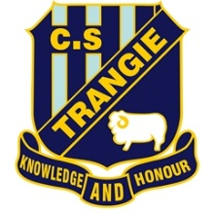
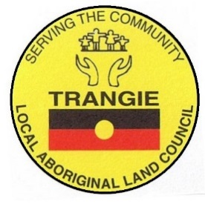
Trangie MPHC

SENIORS OLYMPICS
KURRAJONG COURT, MULLAH STREET, TRANGIE
THURSDAY 9th MARCH 2017
9:00AM – 2:30PM
Morning tea and lunch provided
Join in the activities to enjoy and participate in sporting and recreational activities that will promote good health and active ageing. Join in the fun and you might just win a prize.
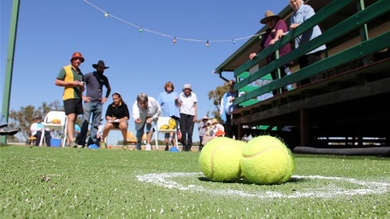
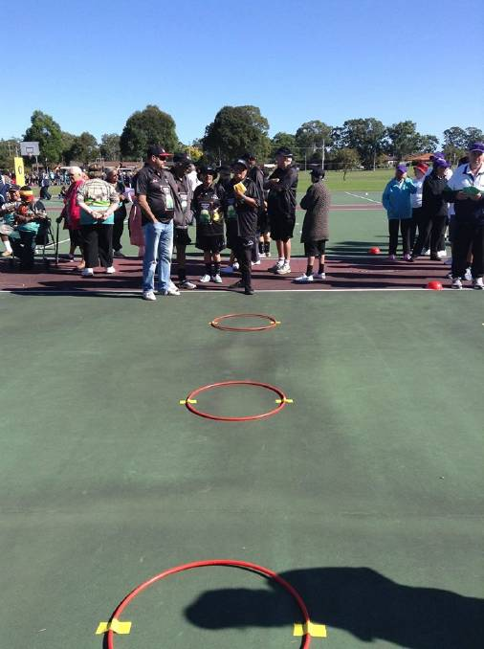
- Quoits
- Netball
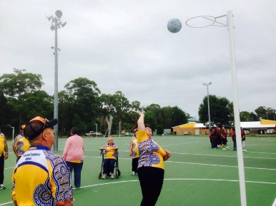
- Bocce Ball
- Trivia
- Thong throwing
- Team events
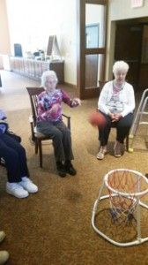
- Traditional Indigenous games
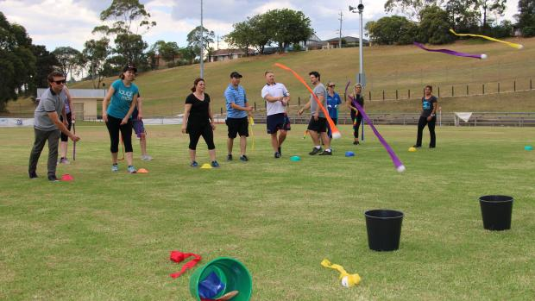
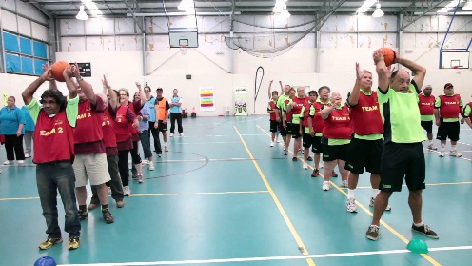
Everyone is welcome to come and join in the fun
For information on the event call Terrie Milgate on 0427887476

