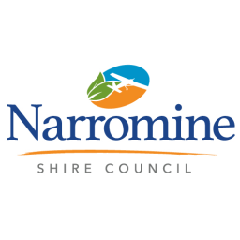
Narromine Shire Council
PO Box 115
Narromine NSW 2821
Phone: 02 6889 9999
Fax: 02 6889 9998

Finished Floor Level Application

Property Details: The Assessment/Lot/Section/ DP Number can be found on the Certificate of Title or Rates Notice for the land.

Lot No /s Section DP No/s

Street No Street Name

Town/Location Postcode

Applicant Details:

Name/s

Postal Address

Town/Locality Postcode

Daytime Phone Mob

I declare to the best of my knowledge and belief that all particulars herein are correct in every detail and all information required has been supplied.

Signature/s: _______________________________________ Date:

Fee: Application fee is $100.00

Updated July 2019

